**Model FTI-1.5A**

Single Tank

Automated Diesel Fuel Maintenance System

**Maintenance Manual**

Contents

Page 2: General Maintenance Notes

Page 3: Identifying System Parts

Page 4: Changing the 2-Micron Filter / Water Separator

Page 4: Draining Water Separator

Page 5: Filtration Stages and Replacements

Page 6: Troubleshooting

Page 7: Warranty

**General Maintenance Notes**

1. **Overview**
   1. FTI-1.5A Fuel Maintenance System is designed for ease of operation. Due to its smaller size and weight, it can be installed in most locations easily.
   2. How often you need to clean stored fuel will vary depending on tank conditions and current fuel conditions.
   3. Your FTI system uses a two-stage, filtering and water removal process. It has a 7-day programmable PLC with memory backup. (Memory backup will last approximately 80 hours without power.)
   4. A Vacuum Sensor Alarm, Leak Detector Alarm, Motor Overload Alarm, and a Filter Water Sensor Alarm will automatically turn the system off and sound an audible alarm. A brief alarm description will appear on the touch screen.
   5. A dry contact for general alarm notification (NO) is available in the control panel. The contact can be used for remote alarm status.
   6. Depending on the condition of the fuel to be maintained, you may initially be changing filters more frequently than expected. By monitoring the vacuum gauge, the operator can determine when it is time to change the filter. (Filter plugged factory set at 16-18 in.Hg.). **The filter should be changed every 6 months.**
   7. As the fuel quality progressively improves, you will notice a dramatic drop in filter usage. In cases of extreme contamination, it is recommended that you have your fuel tank polished (cleaned) prior to initial use of your FTI system. The FTI system is designed to keep clean fuel clean. Continued use prevents the fuel from deteriorating again and maintains a healthier environment to protect the engine, the fuel, and the storage tank.

**Identifying System Parts**

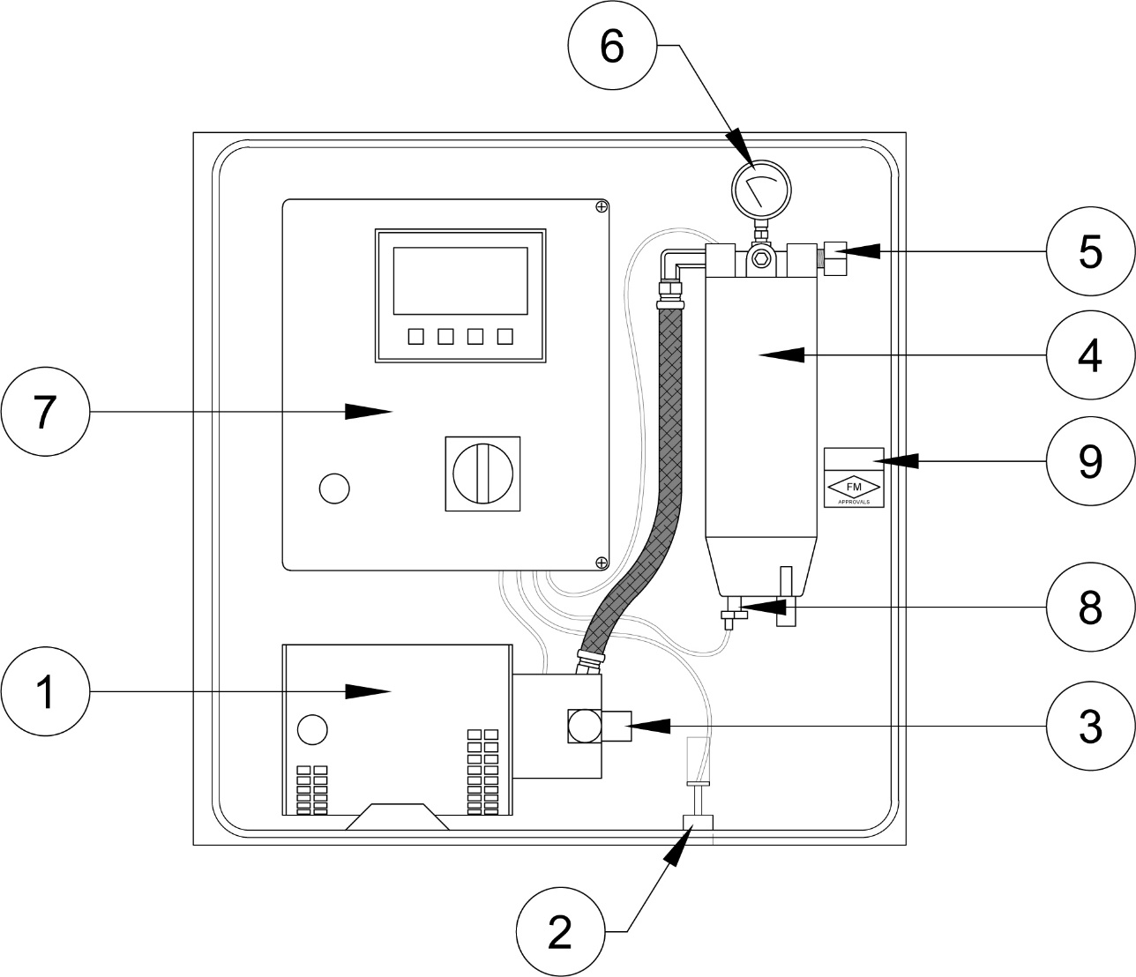

**Model FTI-1.5A Single Tank**

1. Pump / Motor
2. Leak Detector
3. Return Line Connection
4. Water Separator & 2 Micron Filter
5. Supply Line Connection
6. Vacuum Switch Gauge
7. Control Panel
8. Water Sensor

**Changing the 2-Micron Filter / Water Separator**

* 1. Turn off system. Put it in manual mode.
  2. Close inlet and outlet ball valves.
  3. Open drain valve on bottom of filter.
  4. Drain fuel.
  5. Turn counter clockwise and remove.
  6. Remove sight bowl from old filter by turning counter clockwise.
  7. Clean sight bowl and water sensor probe.
  8. Lubricate and install new gasket onto sight bowl.
  9. Turn sight bowl clockwise on new filter and had tighten.
  10. Lubricate rubber seal on top of new filter and turn clockwise until contact is made, then tighten 1/2 to 3/4 of a turn more. **Do not over tighten.**
  11. Restart system, Check for leaks.

Note: Every time system is started, check the vacuum gauge. Vacuum should not exceed 18 in. Hg.

**Draining Water Separator**

1. Open drain valve on bottom of sight bowl to allow water to drain.
2. Close drain valve tightly as soon as fuel appears

Note: The water separator should be drained on a regular basis, even if water is not present every time.

**Filtration Stages and Replacements**

1. **Two Stages of Filtration**
   1. **Stage 1** – 2-Micron fine finish – Replaceable element in filter housing
   2. **Stage 2** – Water separation and removal – Replaceable element in filter housing
2. **Filter Replacement**
   1. **Stage 1 & 2** – FL-R120S (2-Micron & Water Separation Element – 1 ea.)

To order replacement parts, please contact your local rep, or visit [www.fueltech.us](http://www.fueltech.us)

**Troubleshooting Guide**

The following are answers to the most asked questions about the FTI system and potential problems that may occur.

1. **System will not operate / display is not working:**
   1. Check power source (24V DC) and circuit breaker in the FTI panel and wiring. If okay; Contact FTI representative.
2. **Display reads “Filtering XX tank ON” and pump/motor is not running:**
   1. Check pump/motor overload contactor relay (located in control box) reset if needed.
   2. Check the motor overload button located on the motor. (no on all motors)
3. **Leaks – Drip around or on bottom of filter**
   1. Check filter installation and tighten filter if necessary. If this does not stop the leak, check filter seals. Clean or replace seals as necessary.
4. **Water drip**
   1. Close bottom drain valve on filter housing.
5. **Moisture around hose fittings**
   1. Tighten hose fittings.
6. **Vibration**
   1. Check pump-mounting bolts (and all other bolts). Tighten if necessary.
7. **Water sensor malfunction still comes on after draining water.**
   1. Follow the procedure using the Water Sensor Alarm Error (Water Sensor Alarm not shutting off) to flush the sensor elements. (Maintenance Manual – Page 4)

**NOTE\*** - If in doubt or if the problem cannot be resolved, please contact your FTI representative.

**Limited Warranty**

FUEL TECHNOLOGIES INTERNATIONAL (FTI) makes every effort to assure that its products meet high quality and durability standards, and we expressly warrant the original consumer/purchaser of our products that each product is free from defects in materials and workmanship. Our expressed warranty is subject to the following terms and conditions:

1. The term of our warranty is one year from the date of purchase. A warranty claim received by us after one year from the date of purchase will not be honored even if it is claimed that the defect occurred prior to one year from the date of purchase.
2. Our warranty does not cover defects due, directly or indirectly, to misuse, abuse, negligence of others, repairs or alterations done outside of our facilities, or lack of maintenance.
3. Our liability for breach of our express warranty is limited to the repair or replacement of the product, at our cost.
4. We are not liable for general, special, consequential, incidental or contingent damages resulting, directly or indirectly, from the purchase or use of our products.

**WE DISCLAIM ALL WARRANTIES OF MERCHANTABILITY AND FITNESS FOR ANY PURPOSE OF OUR PRODUCTS.**

To make a claim under this warranty, call our Customer Service Representative at 1-805-462-8849. We will ask you to advise us of our Distributor’s name and address, the date of purchase, model number, and a detailed explanation of the problem you are experiencing. The Customer Service Representative will arrange for a Field engineer to inspect your system. If our inspection discloses a defect covered by our limited warranty, we will either repair or replace the defective parts of products at our election, and at our cost. If upon inspection, our Engineer determines there is not a defect or that the damage to the system resulted from causes not within the scope of our limited warranty, then you must bear the cost of repair or replacement of damaged parts. For service, please contact your local Distributor.

*For your records*

Model No. _________________________________ Date of Purchase: ________________________________